3 Advancements in Drug Development for Oncology Research
Posted by Luke Doiron on Feb 10, 2015 7:00:00 AM
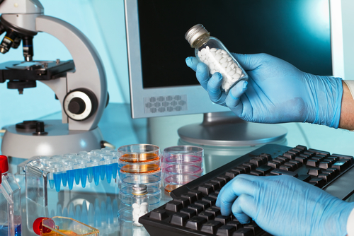
Today, we know a wealth of information about cancer that we didn’t know even 20 years ago. Cancer is now seen as a disease of individual cells with its own molecular circuitry. By determining defects at the molecular level, it becomes possible to intuit and predict how cancer cells will behave, and assign biological properties to understand implications for disease.
Personalized oncology, for instance, is evidence-based, individualized medicine that delivers the right care to the right cancer patient at the right time and results in measurable improvements in outcomes and a reduction on health care costs. Biomarkers and molecular individualized medicine are replacing the traditional “one size fits all” medicine.
There have been many recent advancements in drug development for oncology research in clinical trials. Some of these include:

1.Specific Drug Targets - EGFR
EGFR (Epidermal Growth Factor Receptor) plays an important role in the biology of many different tumors. Using biomarkers found in blood samples, researchers can identify specific targets for the drugs they are developing. For example, Erlotinib, more commonly known as Tarceva, has been helping to make great strides in the fight against late stage non-small cell lung cancer (NSCLC) and pancreatic cancer. The drug targets and inhibits the epidermal growth factor receptor (EGFR).

2. Specific Targets - ASCL1
Recently, Mayo Clinic researchers have discovered that the protein ASCL1 combined with a high level of RET can lead to an increased chance of smoking-related lung cancers. Researchers were able to block the ASCL1 protein, causing the cancer tumor growth to slow. Because of this research, they believe that this biomarker could be a target for drug discovery and a potential candidate for clinical trials.

3. Surrogate Endpoints
Biomarkers are also being used to indicate whether or not disease progression is being slowed down by a particular drug. This can save companies the long and expensive process of beginning clinical trials if a drug fails to show that it will increase patients’ chances of survival.
Circulating tumor cells (CTCs) and microRNA (miRNA) are currently being tested as surrogate endpoint biomarkers (SEB). Found in blood, they can serve as a predictor of disease onset or relapse. Some hurdles to these particular biomarkers’ adoption are the difficulty in enriching, identifying, and measuring their levels in the blood.
Researchers have long been trying to identify the “Achilles' Heel” of the cancer cell, and identify where it gets “short circuited.” To date, there are hundreds of clinical trials evaluating targeted cancer therapy. It takes years of hard cancer research to unlock all of the genetic mutations associated with aggressive cancers. By studying the molecular and biological changes in tissues, both normal and cancer, scientists are better able to design unique drugs and even back up drugs in the arsenal against cancer.The advancements in cancer drug discovery have really exploded in the last decade, including the advancements listed above.

